LAPORAN PRAKTIKUM 2
OPERASI DASAR CITRA

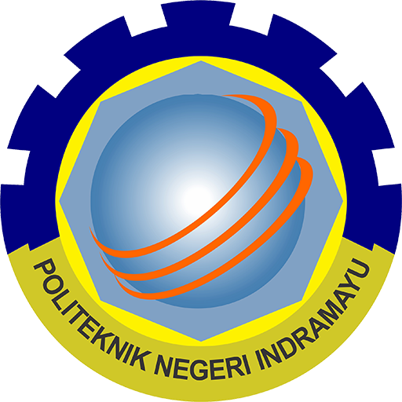

OLEH;
MUHAMMAD RAFLI (2303099)

POLITEKNIK NEGERI INDRAMAYU
JURUSAN TEKNIK INFORMATIKA
2025

A.TUGAS INDIVIDU

Task 1 : Pixel Operations
Perform the pixel operations on the image (min 2):

Task 2 : Arithmetic Operations
Perform the arithmetic operations on the image (min 2):
Task 3: Boolean Operations
Perform the boolean operations on the image (min 2):
Task 4: Geometric Transformations
Perform the geometric operations on the image (min 2):

B.JAWABAN PRAKTIKUM

1.Pixel Operations

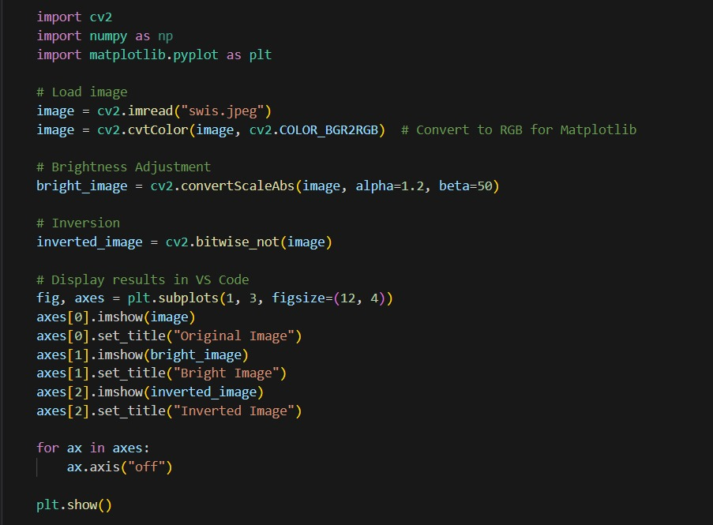

Hasil
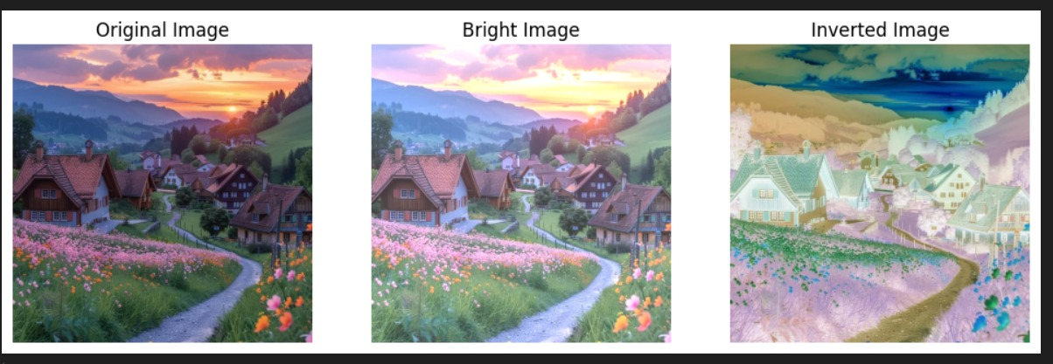

2. Arithmetic Operations

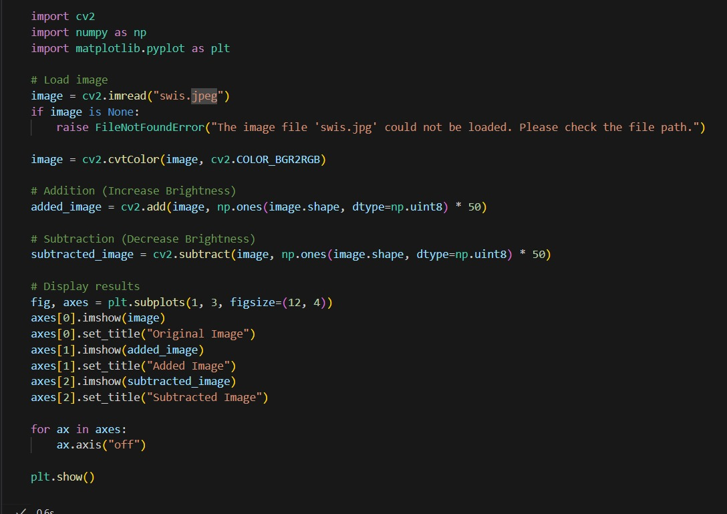

Hasil

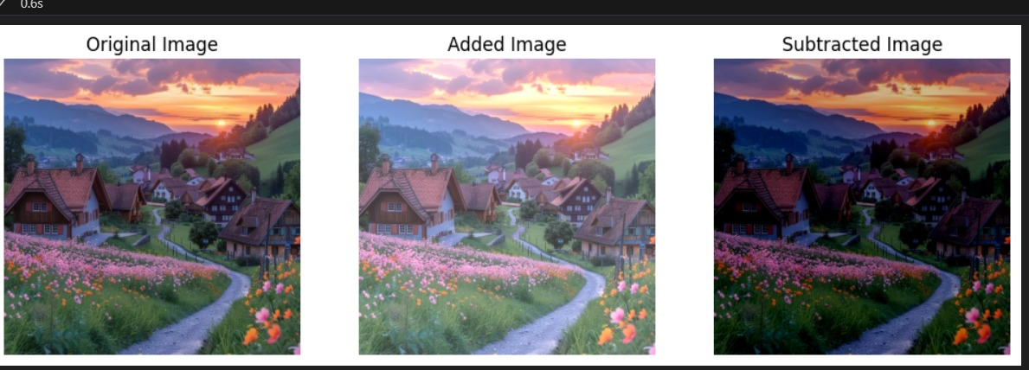

3. Boolean Operations

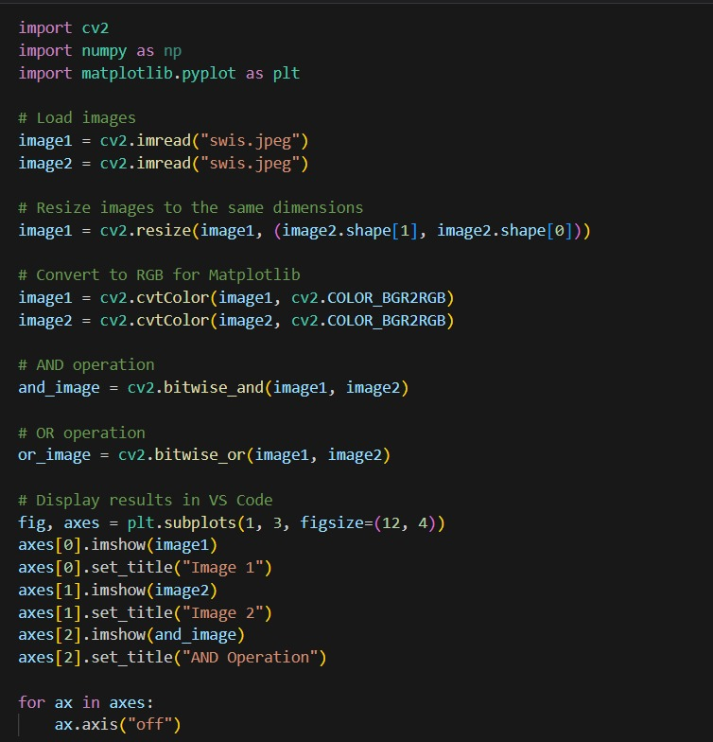

Hasil
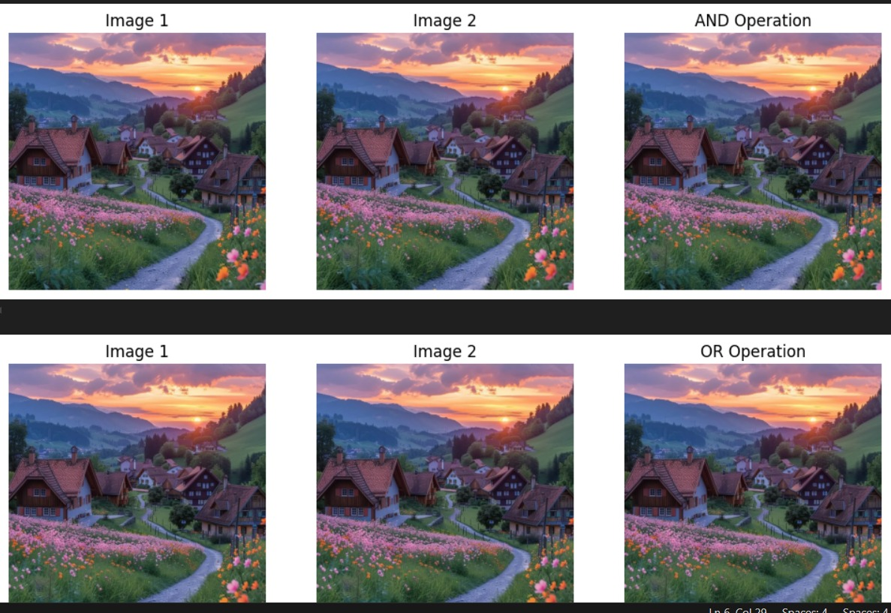

4. Geometric Transformations

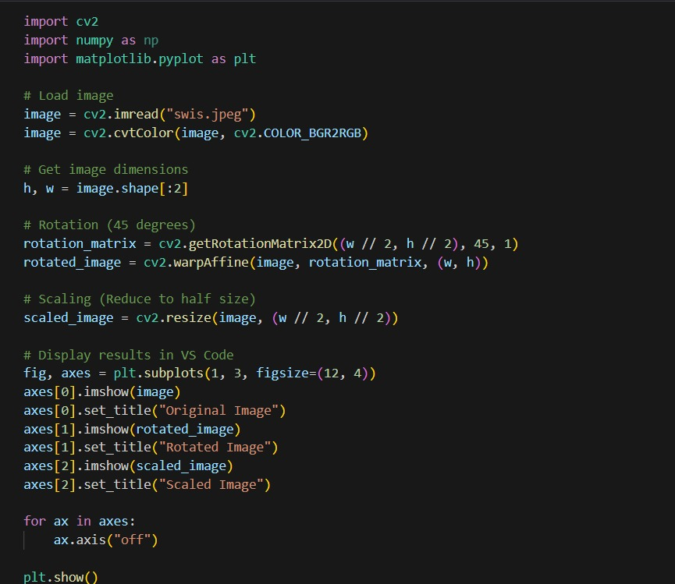

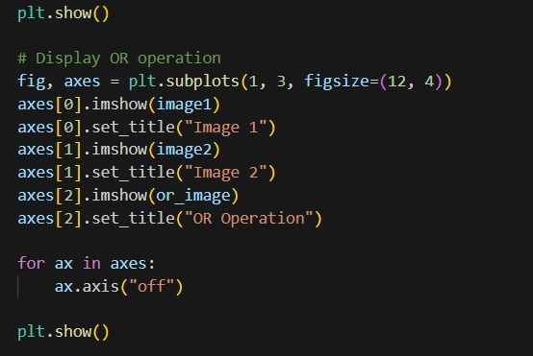

Hasil

